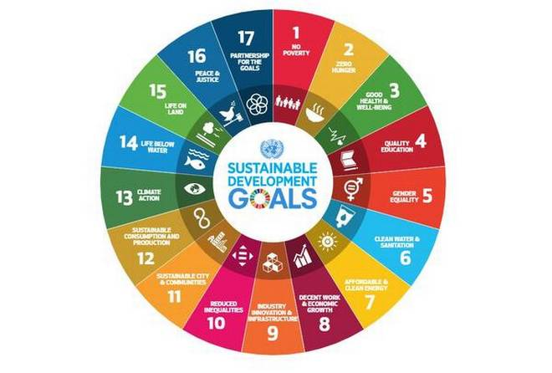



**India SDG Dashboard**

User Interface Guide

Contents

Chapter 1: Introduction 3

CHAPTER 2: Home Page 5

CHAPTER 3: Overview 7

CHAPTER 4: India 8

Goal View 9

Target View 11

Indicator View 12

State and District View 13

CHAPTER 5: State 14

CHAPTER 6: Metadata 15

CHAPTER 7: Search 16

# Chapter 1: Introduction

The Sustainable Development Goals (SDGs) are an ambitious commitment by world leaders which set out a universal and an unprecedented agenda which embraces economic, environmental and social aspects of the wellbeing of our societies. SDGs have been adopted by all United Nations Member States in 2015 at the 70th session of the United Nations General Assembly (UNGM). It is call to action to end poverty, protect the planet and ensure that all people enjoy peace and prosperity by 2030. The SDG framework consists of 17 goals and associated with 169 targets and 469 indicators.

The progress of the world to meet the SDGs, largely depends on India’s progress. India played a prominent role in the formulation of SDGs. India adopted a Global Indicator Framework, consisting of 232 unique Indicators. National Institution for Transforming India (NITI Aayog) has the overall responsibility of SDGs implementation and align government schemes/ programs to SDGs. The Ministry of Statistics and Programme Implementation (MoSPI) developed the National Indicator Framework (NIF). The NIF currently comprises 306 indicators for different targets and goals.

The objectives to develop a central comprehensive India SDG dashboard is to:

* Integrate existing data of the all stakeholders in one system
* Create SDG indicators based database guided and owned by MOSPI and other stakeholders
* Track, monitor and report on the National SDGs Indicator framework
* Develop a data portal to host the SDG dashboard and provide admin panel to manage the data centrally

The India SDG dashboard is a web-based application software. The dashboard comprises of the two applications – User Interface and Data Manager. This user manual is developed for the users who would like to learn how to use the user interface application. This User Interface application comprises of the following modules:

1. Home Page
2. Overview
3. India
4. State
5. Metadata

You can access the user interface application by using a web browser (recommended browser - Google Chrome latest version). You would need an internet connection and this application is open to all and does not have any user access restrictions.

# CHAPTER 2: Home Page

Type the URL <http://itmcloud.org/india-sdg/frontend/> in a web browser. You will land on the home page of the application (see below figure). The top left corner shows the ministry logo, in the center, there is a SDG wheel where you can click and learn more about the SDG goals. And on the right of the wheel you can see an introduction text for the India SDG dashboard. Now, click on the Explore SDGs arrow to navigate to the other modules of the application (explained in following chapters).

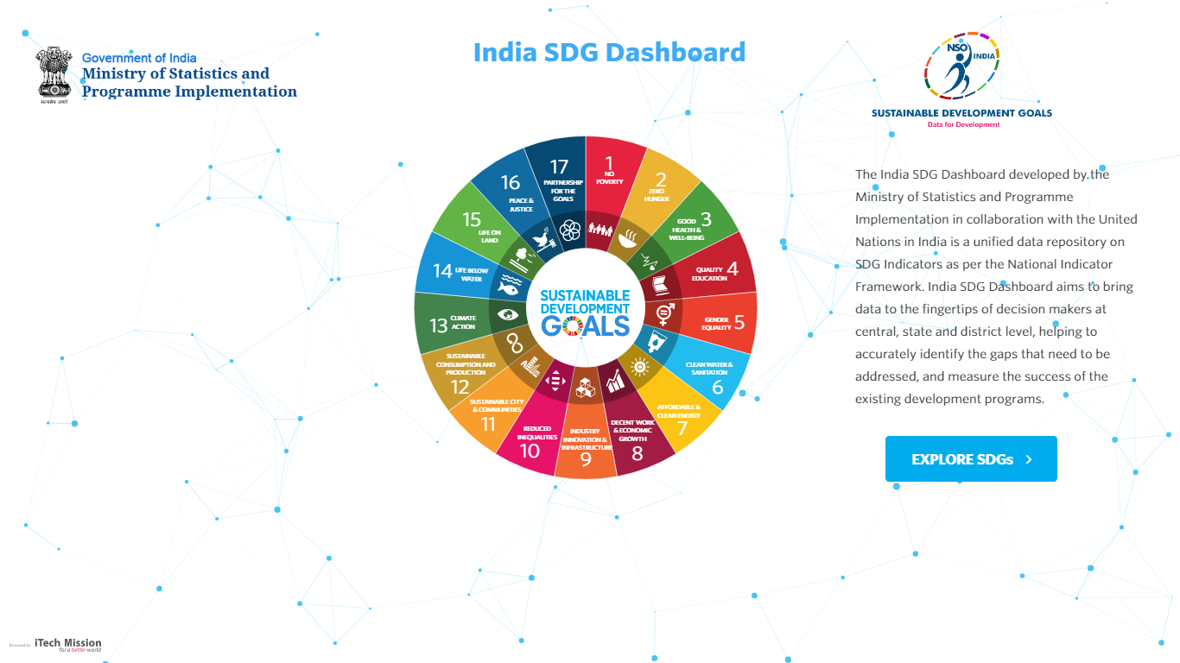

The SDG wheel shows the 17 goals. If you're willing to view details of any particular goal, simply click on the stroke as per your choice (see below figure). There is an arrow with each goal content and by clicking on that arrow you can jump directly to that goal’s dashboard on India page.

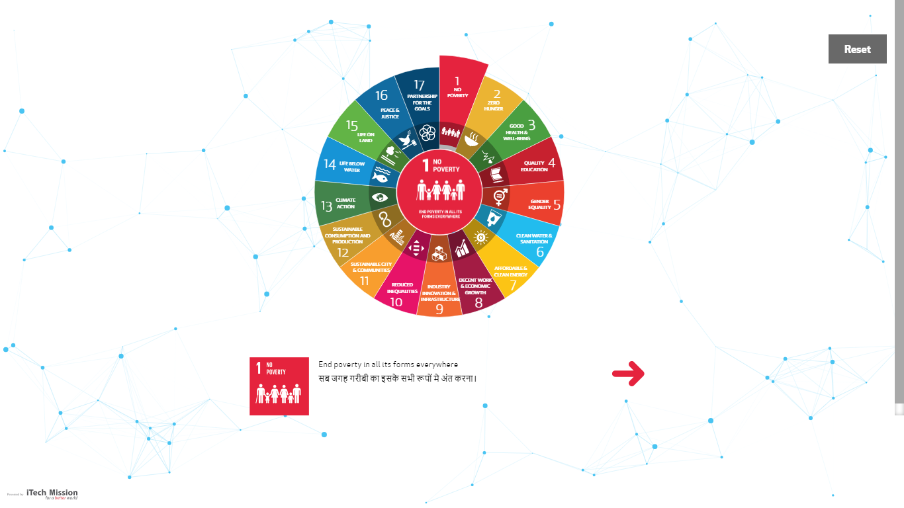

Click on the **Reset** button to navigate back to the home page of the application**.**

# CHAPTER 3: Overview

By clicking on the Explore SDGs button on the home page it will take you to the overview page of the application. This page has two sections –The left section which can be displayed by clicking on it and then you can navigate to all the 17 goals. The right section shows the targets of the selected goal. By default, the first goal and its target can be seen without any selection.

You can select a goal from the left section by clicking on the SDG wheel. The definition of the selected goal is shown under the SDG wheel and its targets are shown in the right section.

The overview page contains a banner on the top left corner that allows navigating to the home page from the other pages. On the top right corner, you will find the search button. You can click this button to search/explore the indicators.

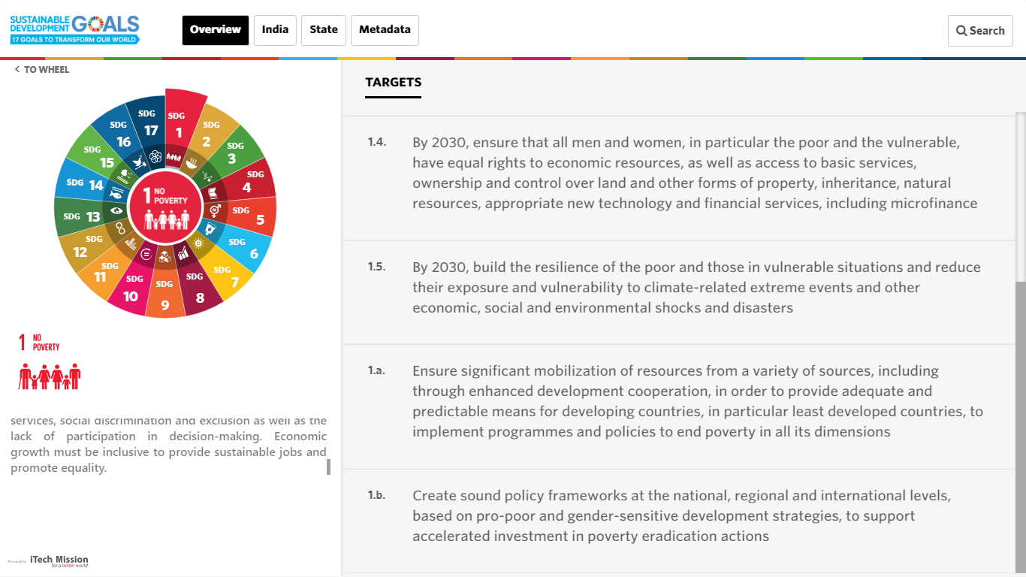

# CHAPTER 4: India

This is the main module of the application. You can access this module either by clicking on the arrow present with each SDG content on the home page or you can click on the India tab on the dashboard application.

This page has two sections- The left section is the navigation section and the right section displays the visualizations. By default, the first goal is already selected and its targets and indicators can be seen in the right section.

The navigation section on the left side has five drop down lists –Goal, Target, Indicator, State and District. Each drop down list generates a dashboard view in the right section. The right section view shows the SDG indicators data in visualization widgets. Later in this chapter, we will learn how to use the visualization widget.

Below is the table to explain the selection from the lists and the views it generates:

|  |  |  |  |  |  |
| --- | --- | --- | --- | --- | --- |
| # | View | Indicators | Area | Disaggregation | Time Period |
| 1 | Goal | Visualization widgets for each indicator by all targets of the selected goal | India | Default subgroup like "Total” and if data for default subgroup is not available then show disaggregated data | All time periods |
| 2 | Target | Visualization widgets for each indicator of the selected goal and target | India | Disaggregated data and if disaggregated data is not available then show default subgroup | All time periods |
| 3 | Indicator | Color theme map for the selected indicator of the selected goal and target | States and if data for states is not available then show India data in visualization widget | Default subgroup along with option to change disaggregation if disaggregated data is available | Most recent data along with option to change time period if data is available for multiple time periods |
| 4 | State | Color theme map for the selected indicator of the selected goal and target | Selected state | Default subgroup along with option to change disaggregation if disaggregated data is available | Most recent data along with option to change time period if data is available for multiple time periods |
| 5 | District | Currently Not available | - | - | - |

Let us now understand each of these views in detail.

## Goal View

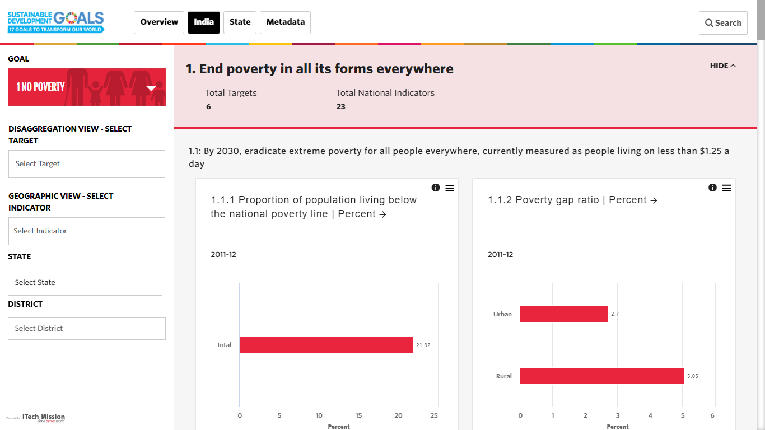In the left section, the first drop-down list is used to select a Goal. Click on the drop-down list and select a goal. The right section shows all the indicators of the selected goal grouped by its targets. The right section starts with a header that shows the goal name along with the number of targets and indicators of the selected goal. You will also find a Show/Hide option in the right corner of the header. Below the header, the indicators are shown in visualization widgets grouped by the targets (see below figure). The table above explains the use cases of the visualization parameters.

Each visualization widget is generated for a unique combination of Indicator-Unit (IU). Let us understand the structure of the visualization widget.

Each **visualization widget** (see below figure) shows the name of the indicator and unit on top. There is an “i” button to the right corner along with a burger menu icon. Click on the “i” button to view the metadata of the indicator-unit combination. Click on the burger menu to open the drop-down list of icons that allows you to change the chart type in the visualization widget. Options are available to change the chart type to bar, column, pie, area, tree map chart types. Further options are available to switch labels on/off, show legend, swap x and y-axis parameters, download chart, view chart in full screen and share the chart on social media like Facebook and Twitter. In the center of the visualization widget, the chart is shown with a time period above the chart. The data 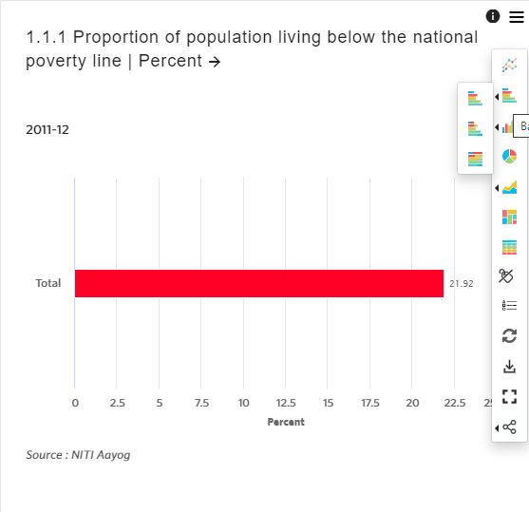source is shown below the chart.

## Target View

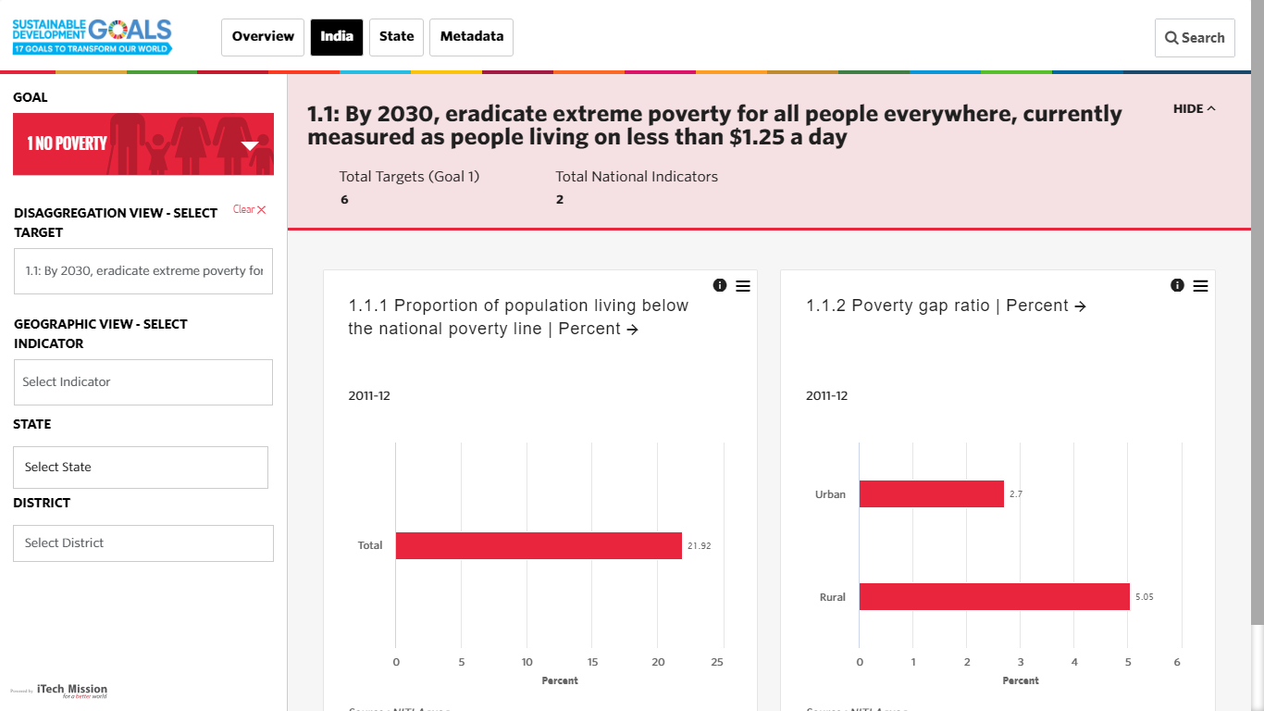The second list on the left section is used to select the target of the selected goal. Click on the second drop-down list and select any target. The right section shows all the indicators of the selected goal and target. The right section starts with a header that shows the goal name along with the number of targets and indicators of the selected goal. You will also find a Show/Hide option in the right corner of the header. Below the header, the indicators are shown in visualization widgets of the selected target (see below figure). The table above explains the use cases of the visualization parameters.

## Indicator View

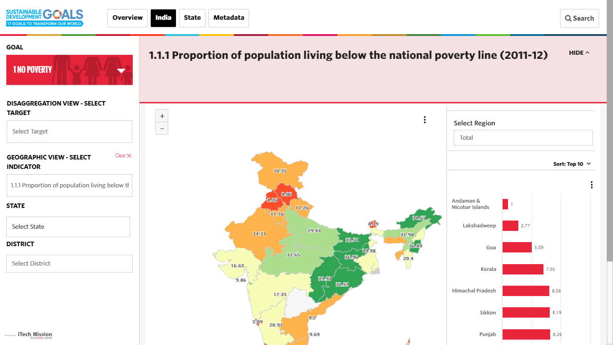The third list in the left section is to select an indicator of the selected goal and target. Click on the third drop-down list and select an indicator. The right section starts with a header that shows the indicators name and a show/hide option on the right corner of the header. Below the header, you can see a color theme geospatial map of the state-level that depicts the selected indicator data. The data ranges are calculated by calculating the number of data values along with the minimum and maximum data values. Each data range is represented by a default color (see below figure). To the right side of the map, you will see drop-down lists to select disaggregation and time period when data is available for multiple disaggregation and time periods. Below the drop- down list, you will see a map data that is presented in a bar chart. The table above explains the use cases of the visualization parameters.

## State and District View

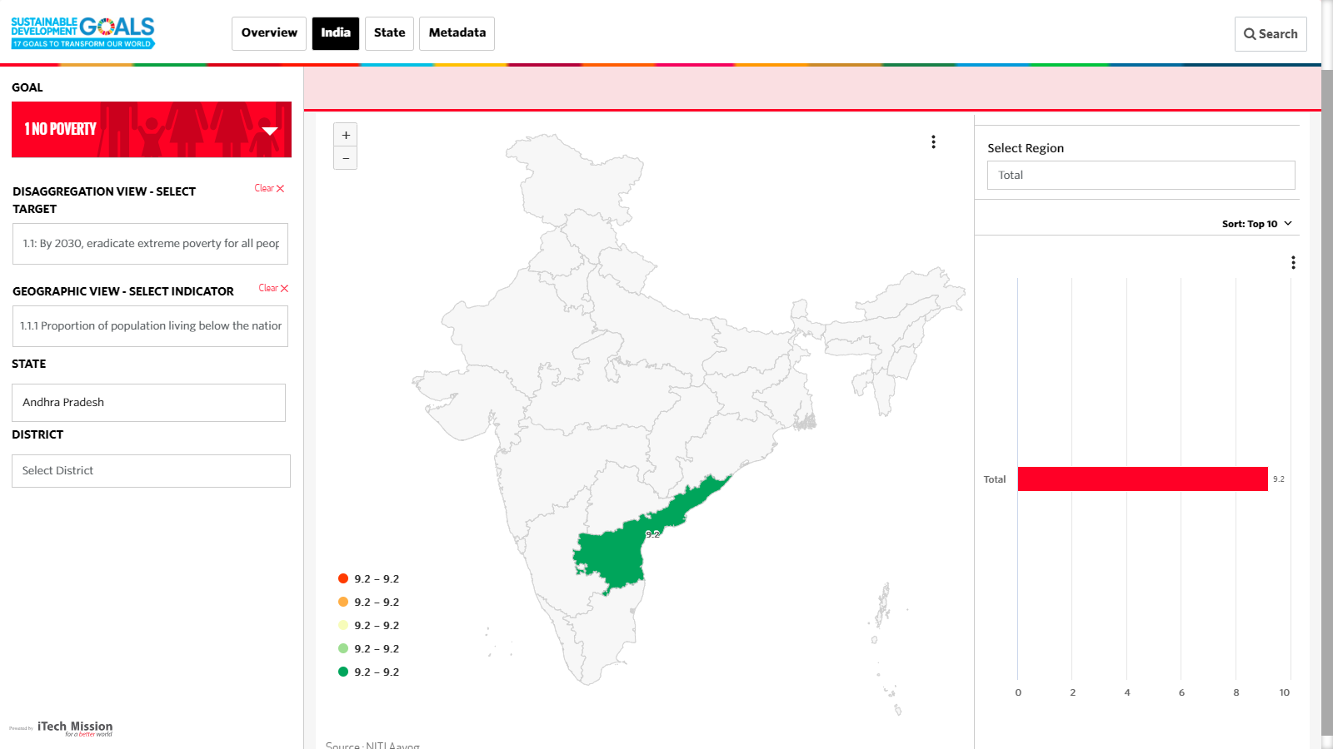The fourth and fifth list on the left section is to select a state and a district to view the data of the selected indicator, goal and target. Click on the fourth drop-down list and select a state. The right section starts with a header that shows the indicator’s name and a show/hide option on the right corner of the header. Below the header, the map shows the selected state in the map of India (see below figure). To the right side of the map, you will see drop-down lists to select disaggregation and time period when data is available for multiple disaggregation and time periods. Below the drop-down list, you will the map data is presented in a bar chart. The table above explains the use cases of the visualization parameters. Selecting district from the fifth drop-down list works in the same way as selecting a state explained above.

# CHAPTER 5: State

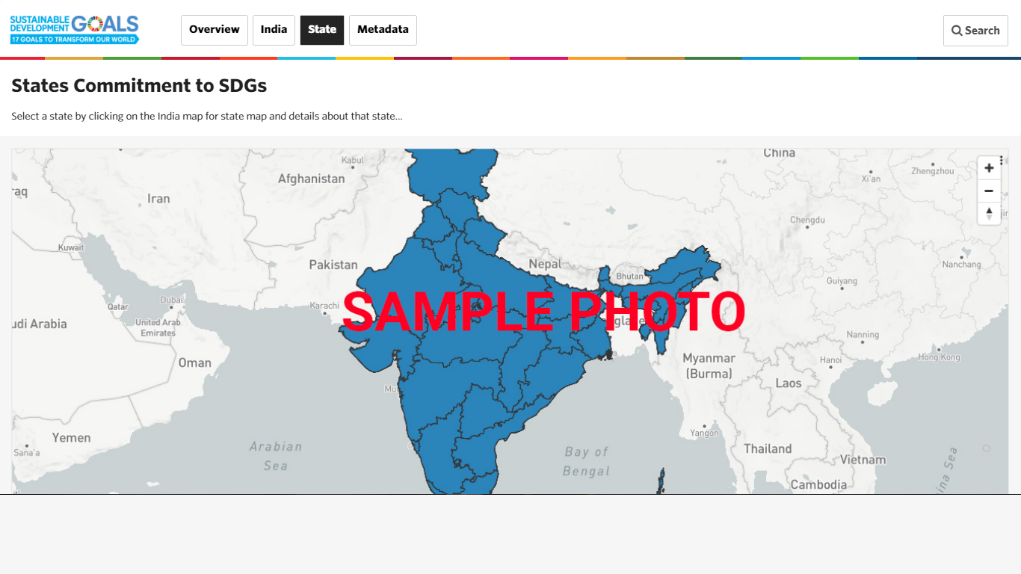The State module will be developed to present the SDG dashboard of each state of India. Currently it shows a sample photo and will be developed in next phase.

# CHAPTER 6: Metadata

Click on the metadata tab to view the metadata of the SDG indicators. The metadata page has two sections – The left section allows you to search and navigate through the SDG framework – Goals and its Targets and Indicators, the right section shows the metadata details of the selected indicator. The metadata details include the following information: indicator name, goal name, target name, computation description of indicator, data source ministry/org, data reference period, periodicity of the indicator, unit of measurement, latest data availability and data dissemination.

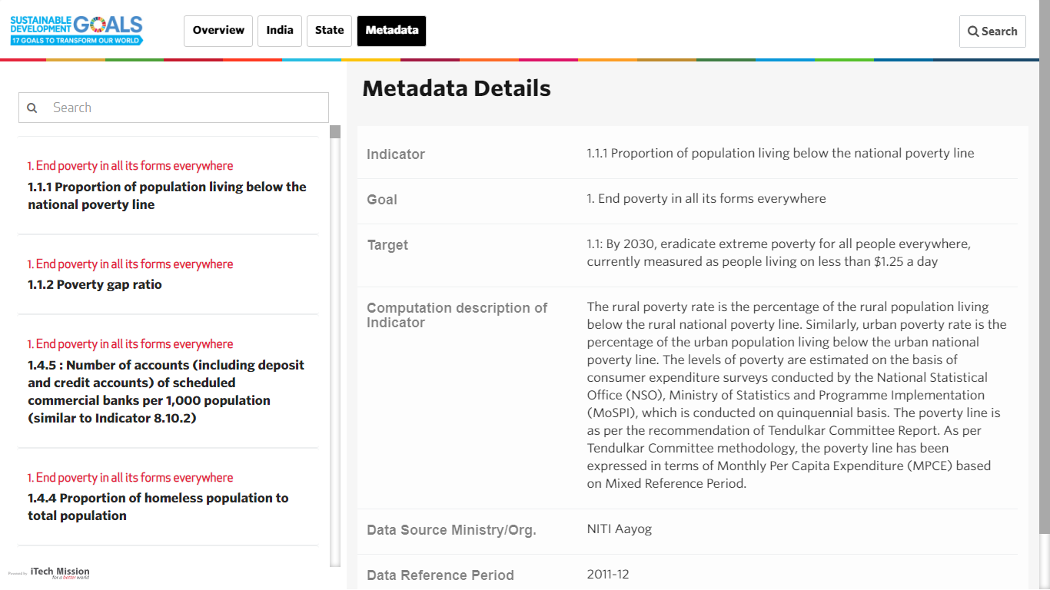

# CHAPTER 7: Search

Click on the search button available on the top right corner on all the pages. The search page allows you to explore the indicators of a selected goal and target. Click on the drop down list to select the required goal and indicator (see below figure).

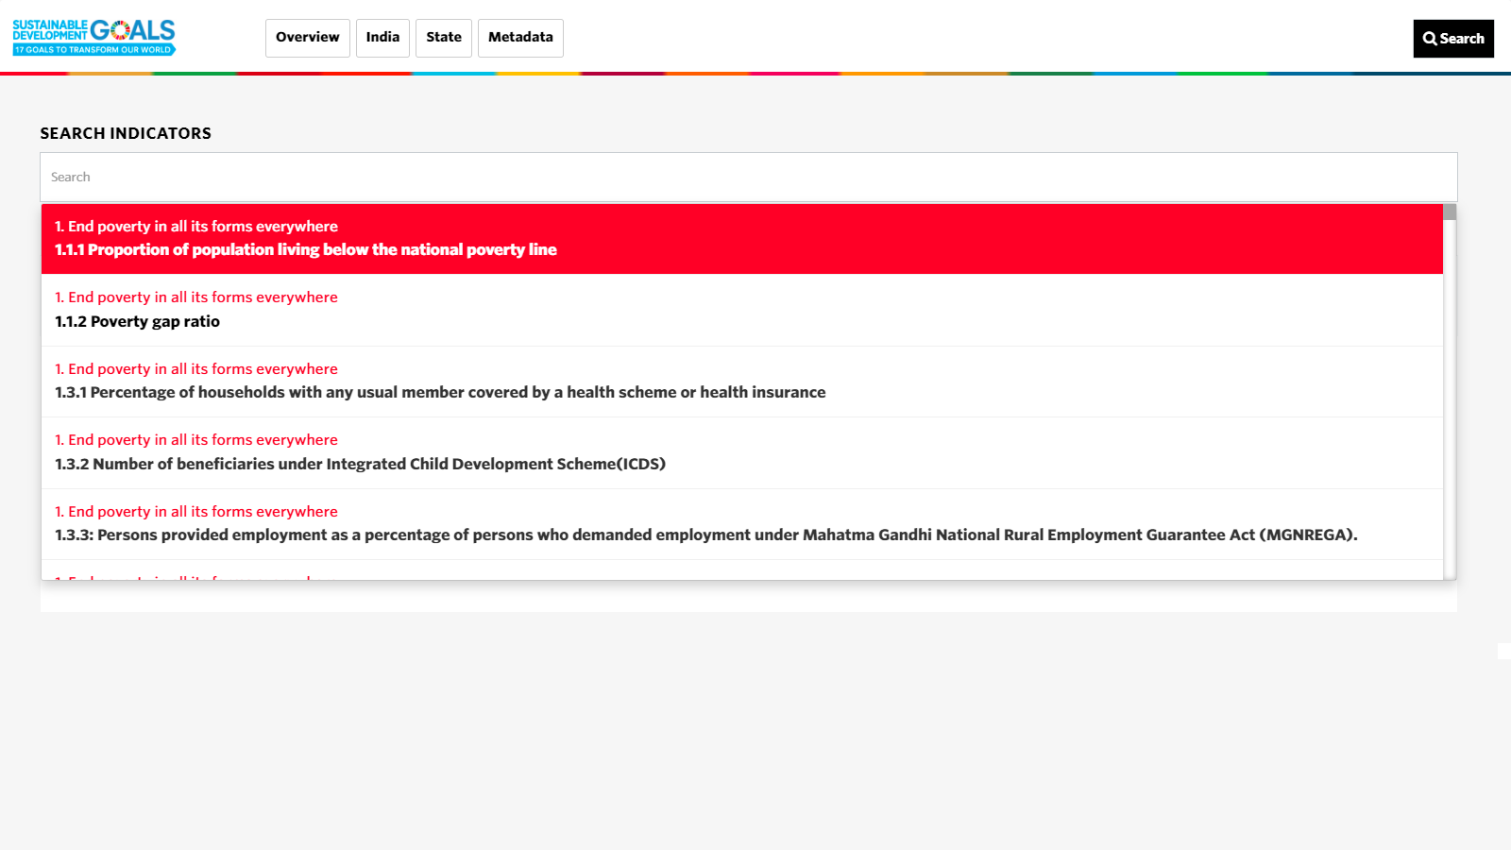

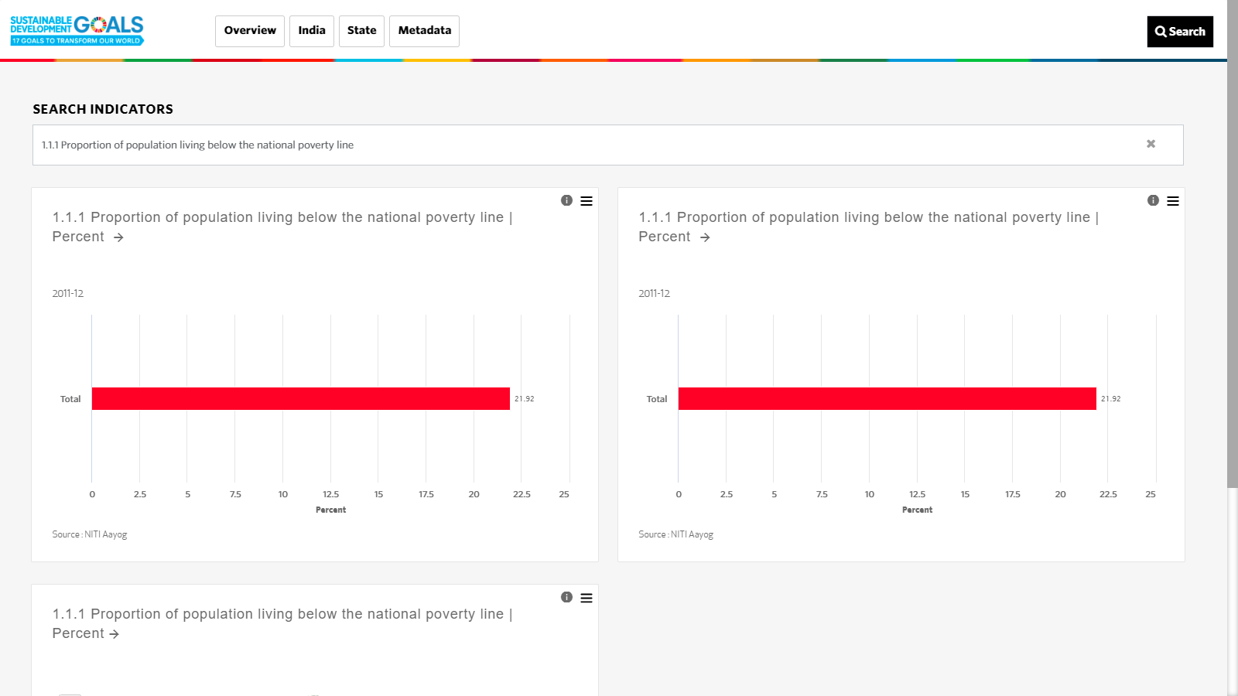You can view the visualization widgets of all the indicator-unit combination of the selected goal (see below figure).

---- End of the document ----